Report

Date | 17 December 2025
Team ID | PNT2022TMIDxxxxxx
Project Name | Title
Maximum Marks | 5 Marks

Introduction
This report presents an analytical overview of child malnutrition indicators using global datasets. Visual charts are included to enhance interpretation and support data-driven insights.
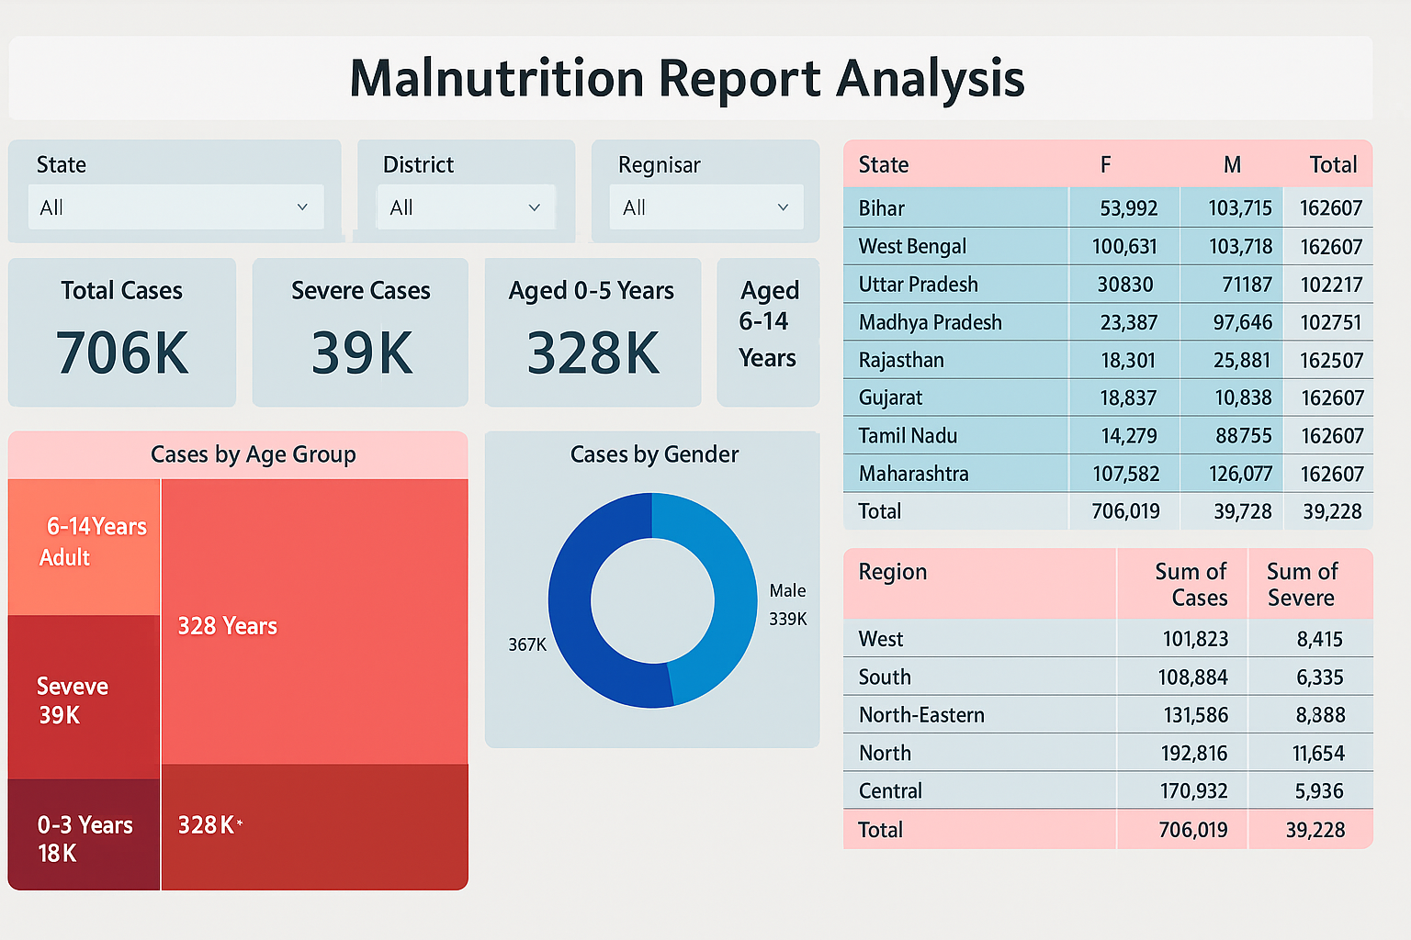

Visual Analysis and Observations
Figure 1 illustrates the top 10 countries with the highest stunting prevalence, indicating severe chronic malnutrition predominantly in low-income regions.
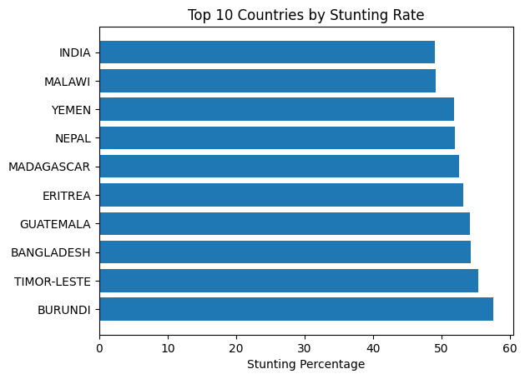
Figure 2 compares average wasting and overweight percentages, highlighting the double burden of malnutrition where undernutrition and overnutrition coexist.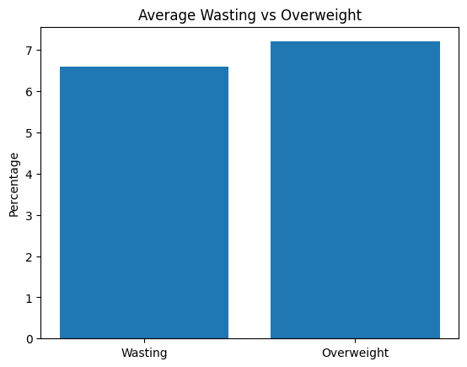

Extended Visual Analysis and Observations
Figure 3 shows the relationship between income classification and average stunting levels. Lower-income groups record significantly higher stunting rates, reinforcing the economic influence on nutrition. 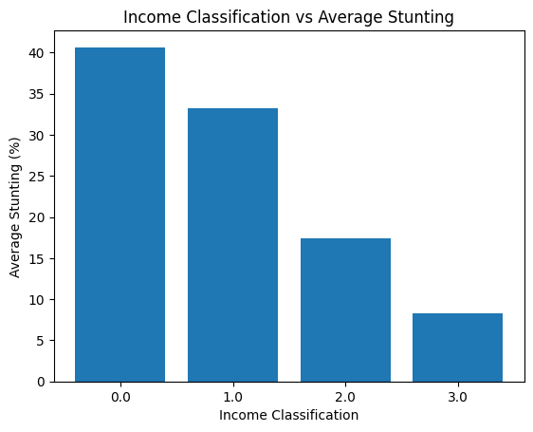
Figure 4 represents the distribution between underweight and wasting indicators. A positive association suggests overlapping forms of acute and chronic undernutrition in seve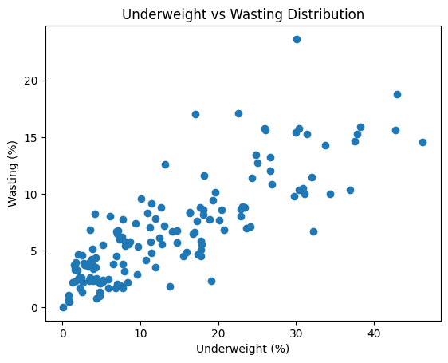ral countries.

Figure 5 highlights the top 10 countries by under-five population size. Countries with larger child populations require prioritized nutritional interventions due to scale of impact.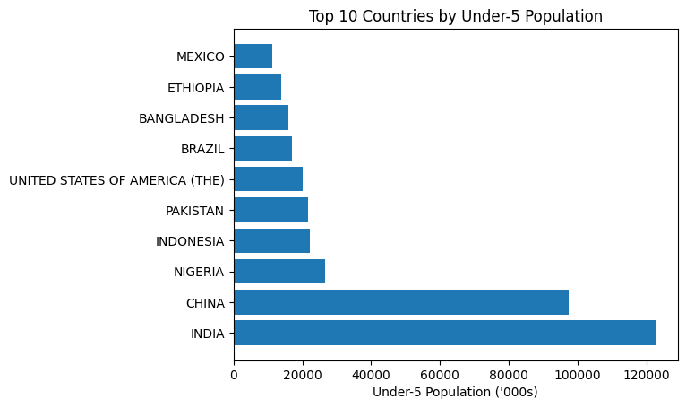

Conclusion
The inclusion of visual charts strengthens the analytical depth of the report. Stunting remains a critical concern in several countries, while rising overweight levels indicate emerging nutritional transitions.

